LMS Online Quiz – Quiz Results

After quiz attempts by the students and quiz close time, results are auto-computed for all the attempts except “Essay” type questions which require manual grading by the teacher.
- Open the quiz link, on the quiz summary page a new link is added mentioning the total number of attempts. Click on Attempts link.
- Quiz results are displayed in a table, each row of the table contains complete records of one student. All answers are auto-marked but descriptive questions require manual grading.

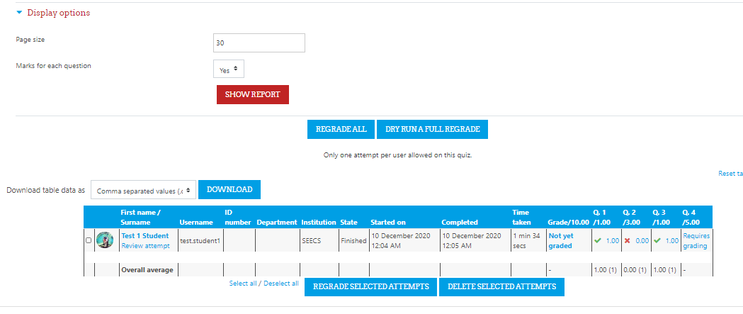

- Click on the “Require grading” link available for descriptive questions.
- Click on the link “make comments or override marks” to manually mark this question. Update the marks and save changes.

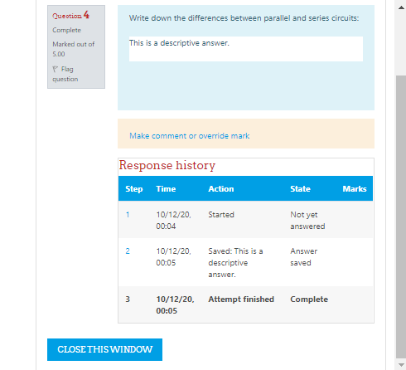

- After updating the manual grades, the results are ready. If manual grading questions are not part of the quiz then a complete results table will be available to the teacher right after quiz close time.

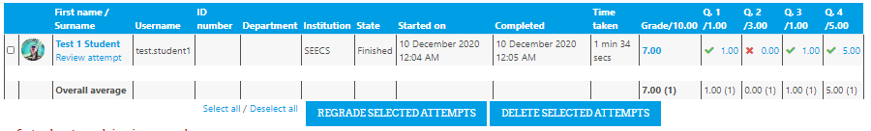

- In case of some mistake in the “right answer” set by the teacher while creating the quiz, the teacher needs to update the correct answer in the question and click on the “Regrade All” button to re-grade all students as per corrected answer.
- Quiz results table can be downloaded as an excel or csv file by selecting the respective option from the dropdown and using the “Download” button.

___________________________

